08
Fall

Prisoner Resource Guide

Legal Support; Free Book Resources; Pen Pal Correspondence; Creative Writing and Artistic Resources; Jobs and Careers; Re-entry Assistance; Family Support; Continued Education

Table of Contents

Legal Support……………………………..………………………..…………………………….2
Free Book Resources ………………………………..…..…………………………………….7
Pen Pal Correspondence ………………………………...……….………………..….……..9
Creative Writing and Artistic Resources …………..…………………………………..12
Jobs and Careers ……………………………………..……………………………………….14
Re-entry Assistance, Family Support, and Continued Education ……………….15

Legal Support -----------------------------------------------------------------------

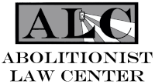
Abolitionist Law Center
Abolitionist Law Center, PO. Box 8654, Pittsburgh, PA 15221 Email: info@alcenter.org Website: https://abolitionistlawcenter.org/. The Abolitionist Law Center is a public interest law firm inspired by the struggle of political and politicized prisoners and organized for the purpose of abolishing class and race-based mass incarceration in the United States. Abolitionist Law Center litigates on behalf of people whose human rights have been violated in prison, educates the general public about the evils of mass incarceration, and works to develop a mass movement against the American punishment system by building alliances and nurturing solidarity across social divisions.

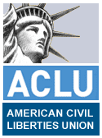
American Civil Liberties Union (ACLU)’s Prisoner’s Assistance Directory
National Prison Project Publications, 125 Broad Street, 18th Floor, New York NY 10004 Tel: (212) 549-2500 Website: http://www.aclu.org/prisoners-rights/prisoners-assistance-directory-2008
The American Civil Liberties Union (ACLU) is our nation's guardian of liberty, working daily in courts, legislatures, and communities to defend and preserve the individual rights and liberties guaranteed to all people in this country by the Constitution and laws of the United States. The ACLU offers the Prisoner’s Assistance Directory, which includes contact information, services, and descriptions for over 300 national, state, local, and international organizations that provide assistance to prisoners, ex-offenders, and families of prisoners. The Prisoner’s Assistance Directory also includes a bibliography of informative books, reports, manuals, and newsletters of interest to prisoners and their advocates. Copies are available for free download. Journal, NPP’s biannual newsletter, features articles, reports, legal analysis, legislative news, and other developments in prisoners’ rights. The ACLU online Newsroom lists the latest news from the ACLU, its affiliates and national projects.

Center on Wrongful Convictions
Through Bluhm Legal Clinic out of Northwestern Pritzker School of Law
375 East Chicago Ave, Chicago, IL 60611 Tel: (312) 503-9576 Email: cwc@law.northwestern.edu Website: https://www.law.northwestern.edu/legalclinic/wrongfulconvictions/.
The Center on Wrongful Convictions is dedicated to identifying and rectifying wrongful convictions and other serious miscarriages of justice. To date, the Center has exonerated more than forty innocent men, women, and children from states around the country, and it receives thousands of inquiries a year. The CWC also houses some of the nation's leading legal experts on false confessions and police interrogations and has helped exonerate more than twenty false confessors.

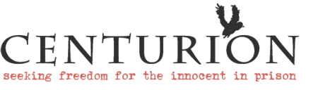
Centurion Ministries, Inc.
1000 Herrontown Rd., Princeton, NJ 08540 Tel: (609) 921-0334 Website: https://centurion.org/. Centurion Ministries (CM) is a nonprofit organization with headquarters in Princeton, New Jersey. CM has a national network of attorneys and forensic experts who ably assist us in our work on behalf of the convicted innocent throughout the U.S. and Canada. The primary mission of CM is to vindicate and free from prison those who are completely innocent of the crimes for which they have been unjustly convicted and imprisoned for life or death. We also assist our clients, once they are freed, with reintegration into society on a self-reliant basis. Centurion is an investigative organization that considers claims of factual innocence in rape and murder cases where an individual is serving a sentence of 15 years before they will be eligible for parole or has been sentenced to death. We do not take on accidental death, self-defense cases, or cases where the defendant had any involvement whatsoever in the crime for which they were convicted. We firmly insist that no one call our office — not yourself, family, or friends. We will not discuss your case with anyone but you, and this is done only through correspondence.

Death Penalty Information Center
1701 K Street NW Ste 205, Washington, DC 20006 Tel: (202) 289-2275 Email: dpic@deathpenaltyinfo.org Website: https://deathpenaltyinfo.org/. The Death Penalty Information Center is a national non-profit organization serving the media and the public with analysis and information on issues concerning capital punishment. Founded in 1990, the Center promotes informed discussion of the death penalty by preparing in-depth reports, conducting briefings for journalists, and serving as a resource to those working on this issue.

EDPUBS via. US Dept. of Education
PO Box 22207 Alexandria, VA 22304 Tel: (877) 433-7827 Email: customerservice.edpubs@gpo.gov Website: https://www.ed.gov/edpubs/
A National organization providing information and referral services. We specialize in human services and criminal justice. We link people with resources in their community such as drug or alcohol programs, educational programs (assistance with reading, writing, and math), volunteer programs, employment assistance, temporary shelter and housing resources, counseling, and other services.

Equal Justice Initiative
122 Commerce St., Montgomery, AL 36104 Tel: (334) 269-1803 Email: contact_us@eji.org Website: https://eji.org/. The Equal Justice Initiative is committed to ending mass incarceration and excessive punishment in the United States, to challenging racial and economic injustice, and to protecting basic human rights for the most vulnerable people in American society. We receive many requests for assistance, and we regret that we have limited resources and are unable to assist in most cases. Please do not send legal materials relating to your case, as those documents will not be maintained. Work is mainly in the southern states.

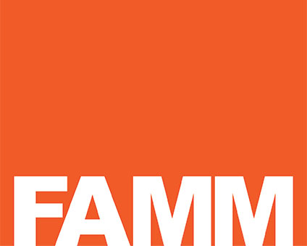
Families Against Mandatory Minimums (FAMM)
1100 H Street NW, Washington DC 20005 Tel: (202) 822-6700 Website: www.famm.org. FAMM is a national nonprofit organization founded to challenge inflexible and excessive penalties required by mandatory sentencing laws. We promote sentencing policies that give judges the discretion to distinguish between defendants and sentence them according to their role in the offense, seriousness of the offense, and potential for rehabilitation. FAMM's 25,000 members include prisoners and their families, attorneys, judges, criminal justice experts, and concerned citizens. You may write for further information.

Innocence Project
40 Worth St, Suite 701, New York, NY 10013 Tel: (212) 364-5340 Email: info@innocenceproject.org Website: www.innocenceproject.org
The Innocence Project was set up as and remains a nonprofit legal clinic. This Project only handles cases where post-conviction DNA testing of evidence can yield conclusive proof of innocence. As a clinic, students handle the casework while supervised by a team of attorneys and clinic staff. Most of our clients are poor, forgotten, and have used up all their legal avenues for relief. The hope they all have is that biological evidence from their cases still exists and can be subjected to DNA testing. All Innocence Project clients go through an extensive screening process to determine whether DNA testing of evidence could prove their claims of innocence. Note: All case submissions and follow-up correspondence will be handled by mail or overnight delivery services only.

Justia
1380 Pear Avenue Ste 2B, Mountain View, CA 94043 Website: https://www.justia.com/criminal/resources/
Justia provides the community with open and free access to the law. We strongly believe that the law belongs to all of us and that everyone should have access to the laws that touch and affect our lives. Justia provides resources on law cases and codes, forms and information on prisoner and constitutional rights. Additionally, Justia has on online resource center for LGBTQIA individuals that are disproportionately impacted by the legal system at https://www.justia.com/lgbtq/criminal-justice/.

Lewisburg Prison Project
PO Box 128, Lewisburg PA 17837 Tel: (570) 523-1104 Email: info@lewisburgprisonproject.org Website: www.lewisburgprisonproject.org
Lewisburg Prison Project educates prisoners as to their civil rights and distributes a variety of legal bulletins and publications, written in non-technical laymen's terms, at a minimal cost. We accept stamps and self-addressed stamped envelopes as payment. Write for a free list of materials offered. The prisoners’ rights handbook, as well as other resources are available at: https://www.lewisburgprisonproject.org/resources.

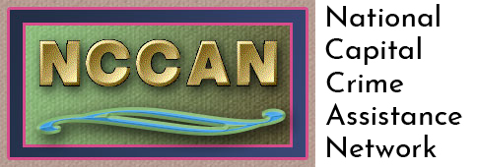
National Capital Crime Assistance Network (NCCAN)
Website: https://nccan.org/. Our work consists of providing support to innocent people who have been unjustly imprisoned and their families. We also have fundraising initiatives to raise money for specific projects, such as retaining an attorney for a prisoner who is ready to take their case back into court. NCCAN offers several links to free resources, as well as a capital defense handbook for the incarcerated community found at https://nccan.org/prisoners-resources

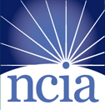
National Center on Institutions and Alternatives
7130 Rutherford Rd., Baltimore, MD 21244 Tel: (443) 780-1300 Website: www.ncianet.org. It is the mission of NCIA to help create a society in which all persons who come into contact with the human service or correctional systems will be provided an environment of individual care, concern, and treatment. NCIA is dedicated to developing quality programs and professional services that advocate timely intervention and unconditional care. Our goal is to reduce the reliance on institutions in criminal justice proceedings by utilizing alternatives such as community service, addressing substance abuse problems, and by using a third-party monitor. We offer pre-sentence investigative services, parole release advocacy, and we provide public information on criminal justice matters. For a full list of services, go to: http://www.ncianet.org/criminal-justice-services/.

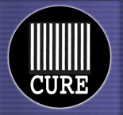
National CURE (Citizens United for Rehabilitation of Errants)
PO Box 2310, National Capitol Station, Washington DC 20013 Tel: (202) 789-2126 no collect calls Email: cure@curenational.org Website: www.curenational.org
A national grass roots organization dedicated to the reduction of crime through the reform of the criminal justice system. CURE is a membership organization of families of prisoners, prisoners, former prisoners, and other concerned citizens. CURE's two goals are to use prisons only for those who have to be in them, and for those who have to be in them, to provide them all the rehabilitative opportunities they need to turn their lives around. Inmates may write to request our newsletter or further information.

National Disability Rights Network
820 First St. NE, Ste. 740, Washington, DC 20002 Tel: 202-408-9514 Website: ndrn.org. The National Disability Rights Network (NDRN) is the nonprofit membership organization for the federally mandated Protection and Advocacy (P&A) Systems and the Client Assistance Programs (CAP) for individuals with disabilities.
As the national membership association for the P&A/CAP network, NDRN has aggressively sought federal support for advocacy on behalf of people with disabilities and expanded P&A programs from a narrow initial focus on the institutional care provided to people with intellectual disabilities in facilities to include advocacy services for all people with disabilities no matter the type or nature of their disability. The National Disability Rights Network does not provide direct legal services or advice to individuals. Legal services must be obtained through the state Protection and Advocacy Systems. https://www.ndrn.org/about/ndrn-member-agencies/

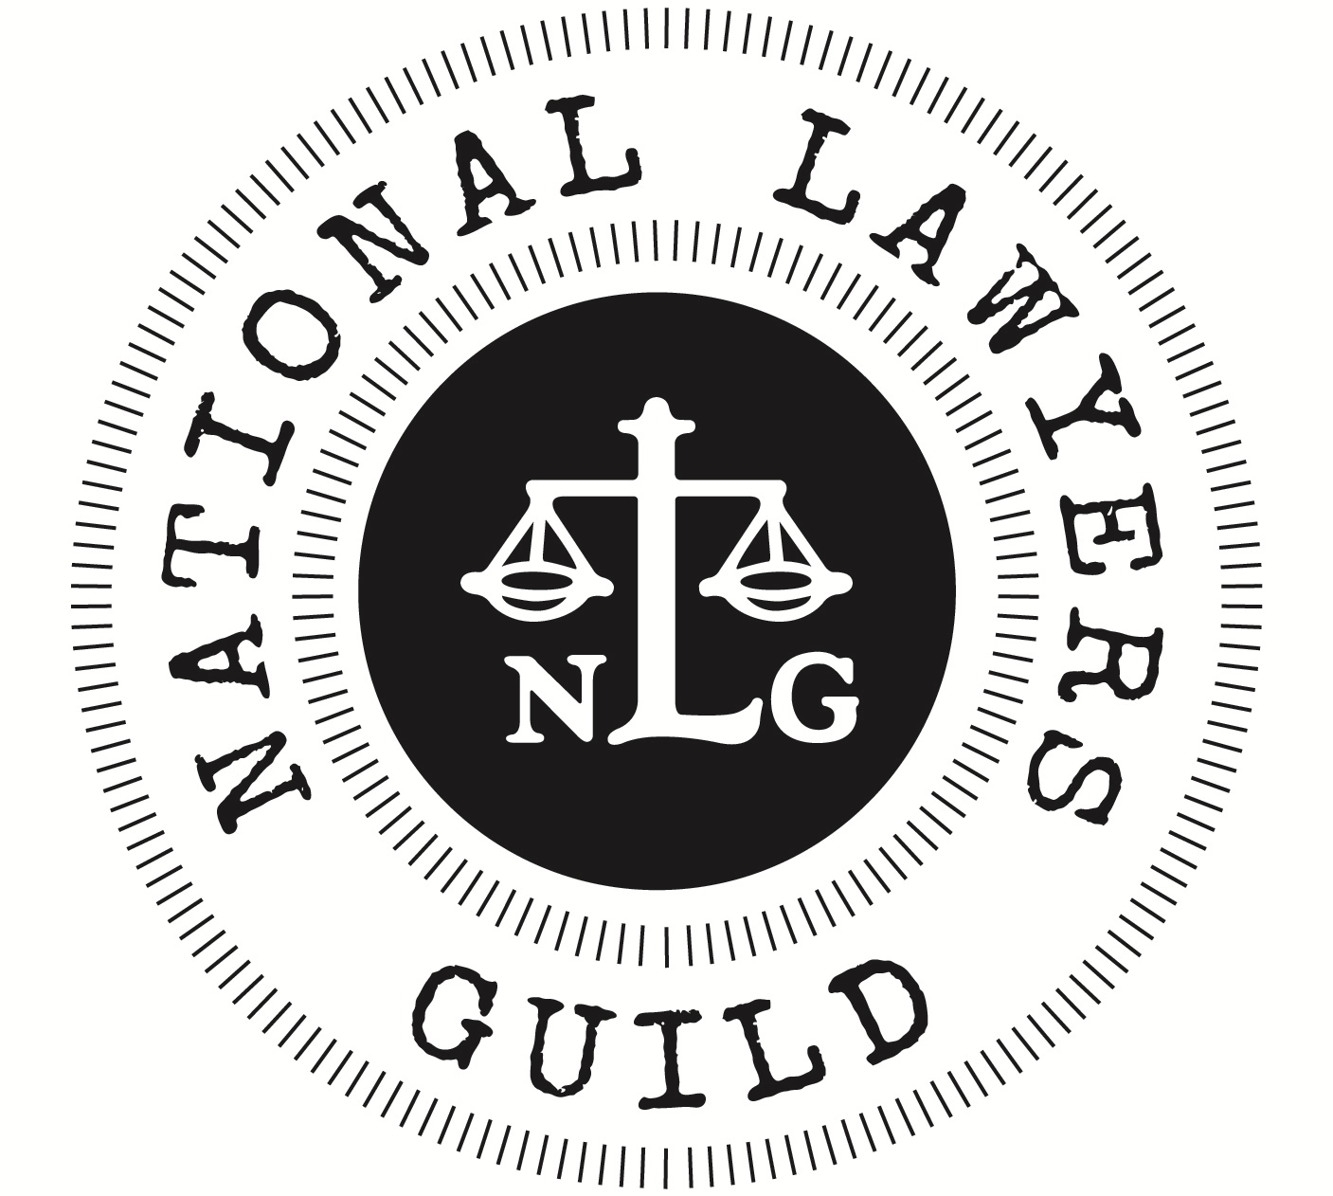
National Lawyers Guild
P.O. Box 1266, New York, NY 10003 Tel: (212) 679-6100 Website: www.nlg.org. The National Lawyers Guild is an association dedicated to the need for basic change in the structure of our political and economic system. We provide self-help law kits free of charge to assist inmates in representing themselves and their own cases or in assisting others. The self-help kits are written in an easy-to-use language that tells you how to file civil complaints, how to deal with grievances, and most other legal matters that you would encounter in the course of being imprisoned. NLG provides a free list of resources at https://www.nlg.org/resources/.

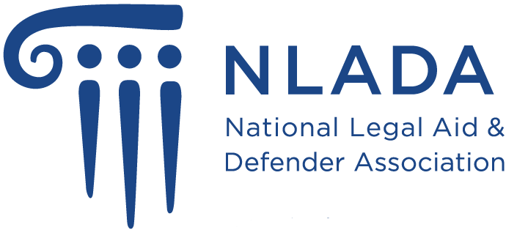
National Legal Aid & Defender Association
1140 Pennsylvania Ave. NW, Suite 500, Washington, DC 20006 Tel: (202) 452-0620 Website: www.nlada.org. NLADA is the nation's leading advocate for front-line attorneys and other equal justice professionals—those who make a difference in the lives of low-income clients and their families and communities. Representing legal aid and defender programs, as well as individual advocates, NLADA is proud to be the oldest and largest national, nonprofit membership association devoting 100 percent of its resources to serving the broad equal justice community. National listing of free legal services.

Office of the Appellate Defender- Reinvestigation Project
11 Park Pl. 16th floor, New York, NY 10007 Tel: (212) 402-4100 Website: https://oadnyc.org/reinvestigation-project/. In cases with evidence of a wrongful conviction, Project attorneys and investigators locate and interview witnesses, collect new evidence, consult with experts, and pursue all possible evidence of innocence. The Project presents compelling cases of wrongful conviction to the Conviction Integrity Units of the Bronx and New York County District Attorney’s Offices, files motions to vacate convictions, and makes other litigation requests. The Project handles both DNA and non-DNA cases.

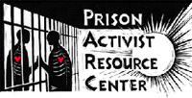
Prison Activist Resource Center (PARC)
PO Box 70447, Oakland, CA 94612 Tel: (510) 893-4648 Email: info@prisonactivist.org Website: https://www.prisonactivist.org/. PARC is a prison abolitionist group committed to exposing and challenging all forms of institutionalized racism, sexism, able-ism, heterosexism, and classism, specifically within the Prison Industrial Complex (PIC). PARC believes in building strategies and tactics that build safety in our communities without reliance on the police or the PIC. We produce a directory that is free to prisoners upon request, and seek to work in solidarity with prisoners, ex-prisoners, their friends and families. We also work with teachers and activists on many prison issues. This work includes building action networks and materials that expose the continuing neglect and outright torture of more than 2 million people imprisoned within the USA; as well as the 5+ million who are under some form of surveillance and control by the so-called justice system. Find more resources here: https://www.prisonactivist.org/resources.

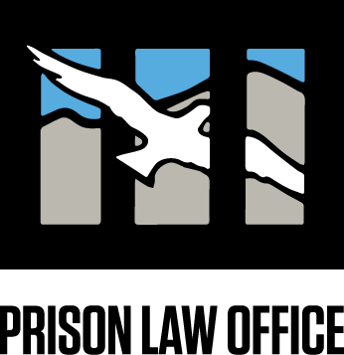
Prison Law Office
Prison Law Office, General Delivery, San Quentin CA 94964 Website: www.prisonlaw.com. The Prison Law Office provides free legal services to California state prisoners (only), and occasionally to California state parolees. Our assistance is generally limited to cases regarding conditions of confinement. The office attempts to resolve such cases informally, if possible (by advocating to prison officials), or through formal litigation. We also offer numerous self-help law manuals free of charge. Visit our resource page at https://prisonlaw.com/resources/.

Prison Legal News
P.O. Box 1151, Lake Worth Beach, FL 33460 Tel: (561) 360-2523 Fax: (561) 828-8166 Email: info@prisonlegalnews.org Website: www.prisonlegalnews.org.
Prison Legal News, a project of the Human Rights Defense Center, is an independent 72-page monthly magazine that provides cutting edge review and analysis of prisoners' rights, court rulings and news concerning criminal justice-related issues. PLN has a national (U.S.) focus on both state and federal prison issues, with some international coverage. PLN provides information that enables prisoners and other concerned individuals and organizations to gain a better understanding of a broad range of criminal justice topics, including issues related to the protection and enforcement of prisoners' rights. Some of the areas we cover include prison labor, the private prison industry, medical and mental health care for prisoners, misconduct and abuse by prison and jail staff, settlements, and verdicts in lawsuits against detention facilities, juvenile justice, the death penalty, the Prison Litigation Reform Act (PLRA), prison censorship, HIV and hep C, solitary confinement, and racial and socio-economic disparities in our criminal justice system.

The Exoneration Project
C/O Intake Department, 311 North Aberdeen St, Third floor Ste. E, Chicago, IL 60607 Email: intake@exonerationproject.org Website: https://www.exonerationproject.org/. The Exoneration Project (EP) works to correct wrongful convictions only in cases where the accused is innocent of the crimes charged, meaning they did not commit the crime(s) and were not involved in the crime(s). We do not take cases where the claim is an affirmative defense, such as consensual sex, self-defense, or accidental death.

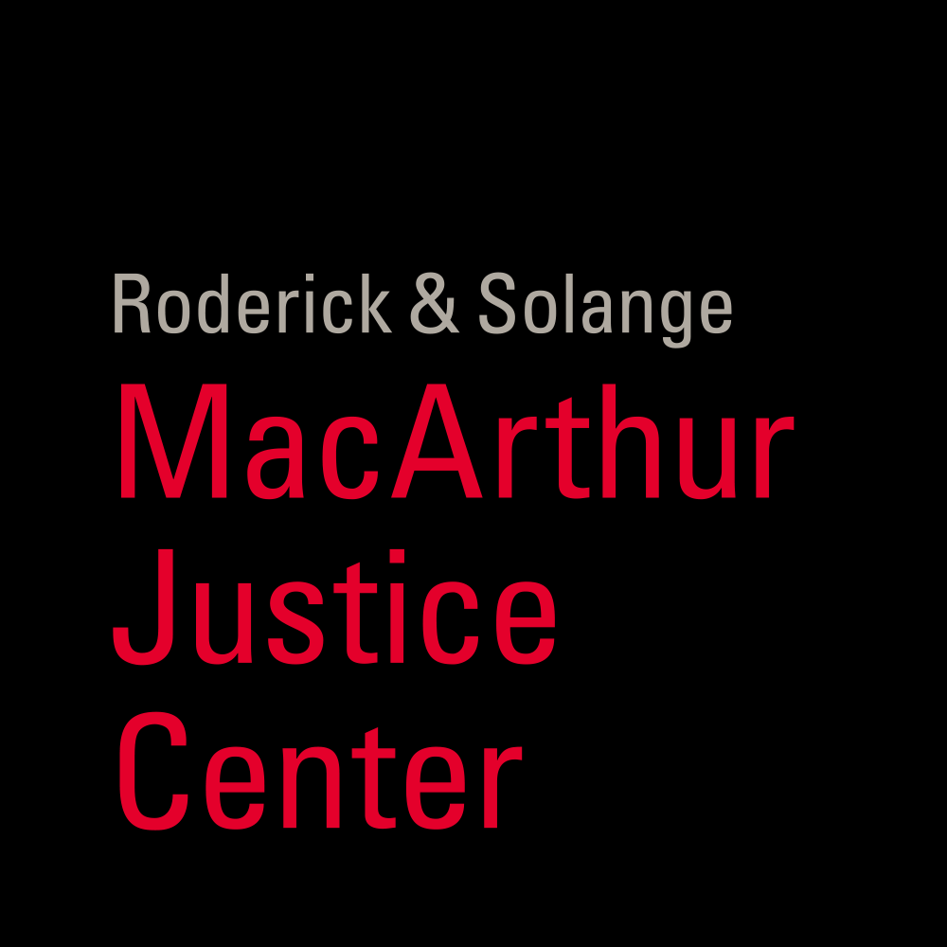
The MacArthur Justice Center
Northwestern Pritzker School of Law, 375 E Chicago Ave., Chicago, IL 60611 Tel: (312) 503-8576 Website: https://www.macarthurjustice.org/. The MacArthur Justice Center is a nonprofit law firm with locations in Illinois, Louisiana, Mississippi, Missouri, and Washington D.C. It takes on cases regarding police misconduct, solitary confinement, wrongful convictions, and class actions around prison conditions and parole. Now also a law clinic at Northwestern law school. Write to Chicago address for other locations. Serves nationwide.

Free Book Resources ---------------------------------------------------------------

The Aleph Institute
9540 Collins Ave, Surfside FL 33154 Tel: (305) 864-5553 Website: www.aleph-institute.org. Aleph is a not-for-profit national organization which has created and implemented a host of programs over the past 20 years that provide alternatives to incarceration, rehabilitate inmates, counsel and assist their families, and provide moral and ethical educational programs inculcating universal truths and concepts common to all of humanity. Jewish inmates may write to receive free books, regular monthly literature, holiday offerings, and family programs.

American Bible Academy
PO Box 1627, Joplin, MO 64802 Tel: (417) 781-9100 Fax (417) 781-9532 Email: info@arm.org Website: http://www.abarc.org/. The American Bible Academy Resource Center provides free downloads of Bible textbooks, commentaries, courses, Gospel tracts and Christian resources. Some material is available in English, Spanish, Russian, and Khmer.

Anthroposophical Prison Outreach Project
1923 Geddes Ave, Ann Arbor, MI 48104 Tel: (734) 662-9355 ext. 38 Email: prisonoutreach@anthroposophy.org Website: https://www.anthroposophyforprisoners.org/.
Do you, as a prisoner, feel that there must be some meaning in your prison experience that is still to be discovered? Or that you can give it meaning? If so, you might be interested in Anthroposophy — the path from the spirit in man to the spirit in the universe. Anthroposophy embraces a spiritual view of the human being and cosmos, but its emphasis is on knowing, not faith. It is a path in which the human heart and hand, and especially our capacity for thinking, are essential. You may write to receive an initial package of literature containing a booklet titled Self-Development in the Penitentiary, as well as other articles and meditation exercises.

Association For Research and Enlightenment
215 67th St., c/o Prison Outreach Program, Virginia Beach, VA 23451 Tel: (800) 333-4499 or (757) 428-3588. Books about the life and work of Edgar Cayce, prayer, meditation, ancient mysteries, dreams, death and the afterlife, reincarnation and karma, the Bible, universal laws, self-transformation, and prophecy. Prisoners are limited to one book every two months.

Books Through Bars
4722 Baltimore Ave, Philadelphia PA 19143 Tel: (215) 727-8170 Email: info@BooksThroughBars.org Website: www.BooksThroughBars.org
We offer a wide range of reading materials free of charge to inmates. Request books by topic and specific subject areas (for example: novels, self-help, American history, etc.). If you wish, you may request specific titles or authors, however, we may not be able to provide these. No legal books. Donations, including stamps, are greatly appreciated. Please send information regarding prison regulations for reading material being sent in. New England Only.

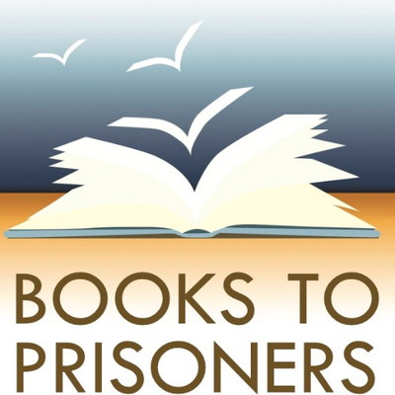
Books to Prisoners (BTP)
92 Pike St Box A, Seattle WA 98104 Tel: (206) 527-3339 Email: bookstoprisoners@live.com Website: www.bookstoprisoners.net
BTP sends donated books to prisoners. Choice of books is limited. Please send a list of topics you are interested in. No legal or religious books available. It may take six to eight months for material to arrive, and donations of stamps are appreciated. To request books from Books to Prisoners, we ask that the person in prison send a letter including their name, prison ID number, and address via physical mail.

Books to Prisons D.C. Area
PO Box 34190, Washington, DC 20043-4190 Email: btopdc@gmail.org Website: http://dcbookstoprisoners.org/. Books to Prisons offers free educational as well as a wide selection of fiction and nonfiction reading material to prisoners around the United States free of charge. Please send requests for your general interests.

Chuang Yen Monastery
2020 Route 301 Attn. Rev. Richard Baksa, Prison Program, Carmel, NY 10512, US Tel: (845) 225-1819 or (845) 228-4299 Website: httsp://www.baus.org/en.
Our organization sends free Buddhist books to prisoners who request them, answers questions regarding Buddhist beliefs and practice that prisoners may have and sponsors a free Buddhist Correspondence Course for prisoners. Available nationwide.

Human Kindness Foundation
PO Box 61619, Durham, NC 27715 Tel: (919) 383-5160 Email: hkf@humankindnessfoundation.org Website: https://humankindness.org/. The Human Kindness Foundation's Prison-Ashram Project sends free books and newsletters to people in prisons and jails all over the U.S., including We're All Doing Time by the late Bo Lozoff. HKF encourages a way of life based upon three common principles taught by the great sages of all religions: Simple living, a dedication to service, and a commitment to personal spiritual practice. Write to request materials in English or Spanish. Limited materials also available to addresses outside the U.S.

The Inside Books Project
3106 E. 14 ½ St., Austin, Texas 78702 Tel: (512) 655-3121 Email: insidebooksproject@gmail.com (preferred) Website: www.insidebooksproject.org
We send books free of charge to Texas inmates only. Please expect a three to six month wait. We also offer a resource list and a free newsletter. Donations and/or stamps are appreciated if possible

ISKON Prison Ministry
PO Box 2676, Alachua, FL 32616, US Email: IskconPrisonMinistry@gmail.com Website: https://iskconprisonministry.org/. Sends free material about bhakti-yoga study and practice, books, prayer beads, CDs, MP3s, and incense. We need to know: 1) Which items you are allowed to have, 2) Are you allowed hardbound or only softbound books? 3) Which items can be sent to you directly and which only through the chaplain? The books cover reincarnation, karma, and how to live a simple, godly life, and find internal peace and joy no matter what your circumstances.

Islamic Society of North America
6555 S. County Rd 750E, Plainfield, IN 46168 Tel: (317) 839-8157 Email: info@isna.net Website: http://www.isna.net. ISNA's vision is to be an exemplary and unifying Islamic organization in North America that contributes to the betterment of the Muslim community and society at large. Sends Qurans and other introductory books on Islamic study to prison libraries and inmates. Ability to send books depends on the prison’s policies. Serves people nationwide.

LGBT Books to Prisoners
C/O Social Justice Center Incubator, 1202 Williamson St. Ste. 1, Madison, WI 53703 Email: lgbtbookstoprisoners@gmail.com Website: https://lgbtbookstoprisoners.org/. We are a trans-affirming, racial justice-focused, prison abolitionist project sending books to incarcerated LGBTQ-identified people in all states except Texas. We do this because we want to acknowledge, and work against, the oppressive functions of the prison system. Our project shifts some control back into incarcerated people’s hands. Incarcerated persons have little access to reading material, and LGBTQ people behind bars have a particularly hard time finding resources that meet their needs and wants. LGBTQ people behind bars face many hardships, including — but not limited to — isolation and physical violence. We want them to know that they have a supportive community on the outside that cares about their wellbeing.

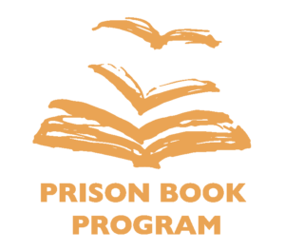
Prison Book Program
C/O Lucy Parson's Bookstore, 1306 Hancock Street, Suite 100 Quincy, MA 02169 Tel: (617) 423-3298 Email: info@prisonbookprogram.org Website:
www.prisonbookprogram.org, You may request topics or titles: limited legal materials, educational, social, political, fiction, and books in Spanish. No catalogue, however, a resource list is available. We do not send books to California, Oregon, Pennsylvania, Michigan, or Texas. Be patient, there is often a wait for a few weeks or months.

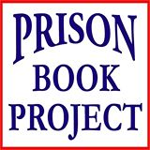
Prison Book Project
1100 S Hopkins Ave., Titusville FL 32780 Tel: (321) 269-4100 Email: touchinglives@prisonbookproject.com Website: https://prisonbookproject.org/. Prison Book was established in 1994 and has been sending books into prisons with one vision in mind to Touch Lives Behind Bars. We desire to introduce prisoners to a saving relationship with Jesus Christ, help them build a firm foundation of faith, and equip them to minister to others, whether they remain in prison or are released.

Prisoners Literature Project
C/O Bound Together Bookstore, 1369 Haight St, San Francisco CA 94117 Tel: (415) 672 - 7858 Email: PrisonLit@gmail.com Website: https://www.prisonlit.org/. We only accept book requests by mail. Let us know the prison’s book restrictions. Are used books allowed, or new only? Are hardcovers OK, or does the facility only accept paperbacks? How many books can we send? Are any subjects prohibited? List subjects or types of books of interest, not specific book titles or authors. We do not have a catalog, because almost all of our books are donated and change every week. We generally have books on history, politics, science, natural history, prison, self-help and psychology, LGBTQ topics, and how-to guides. We also have literary and genre fiction, including African American, Latinx, and Native American titles. We do not carry legal guides, law books, or religious literature. We cannot ship to Texas.

The Prison Library Project
C/O The Claremont Forum, 586 W 1st St., Claremont, CA 91711 Tel: (909) 626-3066 Email: info@claremontforum.org Website: https://www.claremontforum.org/prisonlibraryproject. The Prison Library Project supplies books free of charge to inmates who request them. We try to provide an ongoing invitation to prisoners to embrace personal responsibility, growth, and a deeper appreciation for the world of books, ideas, and education. We offer books on self-help, personal and spiritual growth, wellness, and metaphysical books. No law books, technical, or GED, and no catalogue.

Rogue Liberation Library
PO Box 524, Ashland, OR 97520, US Tel: (541) 482-9625 Website: https://peacehouse.net/RLL/. Rogue Liberation Library, a program of The Peace House, sends free books and reading materials to foster knowledge, creativity, communication, personal development, and well-being. Request books by subject, not specific titles, or authors. List prison book restrictions if known. Does not send to prisons that require all books be new. Does not send legal materials. Limit requests to once every three months. Books are sent free of charge to people in state prisons in the western half of the U.S. and federal prisons nationwide where it is allowed by state and federal regulations.

Women's Prison Book Project (WPBP)
3751 17th Ave S, Minneapolis MN 55407 Tel: (612) 729-5845 Email: womensprisonbookproject@gmail.com Website: www.wpbp.org
Since 1994, the Women’s Prison Book has provided women and transgender persons in prison with free reading materials covering a wide range of topics from law and education (dictionaries, GED, etc.) to fiction, politics, history, and women’s health. We are an all-volunteer, grassroots organization.

Pen Pal Correspondence -----------------------------------------------------------
(Buddhist / Christian / Jewish / Non-Religious)

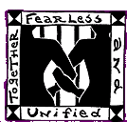
California Coalition for Women Prisoners- Writing Warriors
California Coalition for Women Prisoners, 4400 Market St., Oakland, CA 94608 Tel: (415) 255-7036 ext. 4 Email: info@womenprisoners.org Website: http://www.womenprisoners.org. Writing Warriors is a collective undertaking with others in CCWP to further our mission and programs. Writing Warriors aims to: Establish supportive relationships with women, trans and GNC people at CCWF and CIW; provide limited forms of advocacy for people when possible, based upon the information and methods that CCWP visiting teams use; be a vehicle for sharing written resources and materials and for promoting other forms of collaborative learning. California only.

CellPals!
2003 Southern Blvd SE Suite 102 #59, Rio Rancho, NM 87124 Tel: (855) 736-7257 Website: www.cellpals.com. CellPals! is a prison pen pal organization on the internet that seeks to aid inmates in finding positive influences during a given term of incarceration. You may write to request an application packet from our company. We try to make our site accessible to everyone regardless of financial status.

Christian Pen Pals
PO Box 11296, Hickory, NC 28603 Tel: (828) 256-6100 Email: cppministry@gmail.com Website: https://cppministry.com/. We share the love of Jesus by providing a Christian pen pal for friendship and spiritual help to those who ask, and by networking with other sources of help for other needs common to prisoners. We are here to help prisoners, prisoner's families, and chaplains. Our ministry is therefore focused on proclaiming the Good News of Jesus Christ, His forgiveness, and His great love for all. When prisoners come to know and follow Jesus, hearts are changed. The Holy Spirit gives them power to overcome sin and bondage, giving them a transformed life.

Death Row Support Project- The Church of the Brethren
PO Box 600, Liberty Mills IN 46946 Email: drsp@brethren.org Website: https://www.brethren.org/drsp/. In 1978, concerned Church of the Brethren members formed the Death Row Support Project to facilitate one-to-one correspondence with persons sentenced to death. Since then, thousands of people from all over the country and around the world have responded to the challenge of connecting with death row prisoners.

Inmate-Connection
PO Box 83897, Los Angeles CA 90083 Email: info@inmate-connection.com Website: inmate-connection.com. “Though they may incarcerate the flesh, they can't incarcerate the mind.” This website is dedicated to connecting inmates with the outside world. You may write to request an application form that will give you a full web page on our site. The cost is $20.00 for an entire year. Inmate-connection.com is an excellent place to advertise on the net and get pen pal connections.

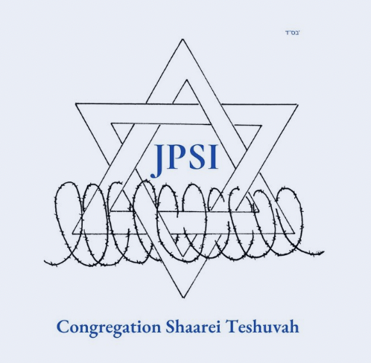
Jewish Prisoner Services International
PO Box 85840, Seattle WA 98145-1840 Tel: (206) 985-0577 Emergency Collect: (206) 528-0363 Website: https://www.jpsi.org/. JPSI provides chaplaincy, advocacy and social services to current and former Jewish inmates and their families worldwide.

Messenger Bible Institute
PO Box 1756, Oakdale CA 95361 Tel: (209) 845-1718 Email: mbimessenger@aol.com Website: http://prisonministry.net/MBI. Messenger Bible Institute offers free Bible correspondence studies and Christian ministry diplomas. They also offer Jail and Prison Ministry Training Programs and Writing Ministries (Pen Pals).

Prison Pen Pals
PO Box 235, East Berlin PA 17316-0235 Email: info@prisonpenpals.com Website: www.prisonpenpals.com. The largest prison pen pal site on the internet since 1996. Thousands of inmates’ personal, legal, and specialty ads are listed on this site, providing prisoners with correspondence opportunities. Write for a brochure.

Creative Writing / Artistic Resources -----------------------------------------

The Beat Within
P.O. Box 34310, San Francisco CA 94134 Tel: (415) 890-5641 Website: http://thebeatwithin.org Email: llava@thebeatwithin.org. Our Beat contributors, most of whom are in the system, from death row to county jail, to various youth facilities, as well as some of whom are now in the free world, are in a unique position to express themselves and realize they are not alone. Through their writings and art, they discover that they are a part of a larger community. Furthermore, their voices reach, touch, and hopefully influence the lives of judges, probation officers, families, community workers, youth, and many others. Our purpose is to educate readers inside and outside of the system. This is why we challenge our writers to think as teachers as they reflect on their pasts and look ahead. Prisoners may send commentaries, artwork, and poetry, directed towards teaching, inspiring, and giving hope. Prisoners may receive a free subscription, donations are appreciated.

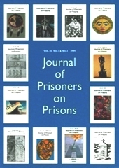
The Journal of Prisoners on Prisons
Subscription Requests and Submissions: Journal of Prisoners on Prisons c/o University of Ottowa Press 542 King Edward, Ottowa, Ontario K1N 6N5 Canada : Tel: (613) 562-6800 ext. 1812 Email: jpp@uottawa.ca Website: www.jpp.org. The Journal of Prisoners on Prisons is a unique forum for the voices of prisoners everywhere. Drawing on writing from prisoners across the world, the JPP allows those most knowledgeable about the realities of prison life and most closely affected by those realities to speak out. The JPP brings us the passionate, articulate voices not previously heard in the ongoing debates about penology, prison abolition, and prisoners' rights. Creative writing, personal stories, artwork, academic, and legal arguments, contribute their perspective to a wide range of contemporary issues related to crime, justice and punishment. Published annually. Submissions: Prisoners and former prisoners are encouraged to submit papers, collaborative essays, discussions transcribed from tape, book reviews, and photo or graphic essays (no fiction or poetry). We publish articles in either French or English.

Pen Prison Writing Program
Pen American Center, 588 Broadway Suite 303, New York NY 10012 Tel: (212) 334-1660 Email: pen@pen.org Website: www.pen.org. Upon request, we will send inmates, free of charge, a short guide offering information on creative writing, places to send your work, how to write a cover letter, and it also includes a list of organizations that provide pen pals. In addition, upon request, we send a free guide for starting your own writing workshops in prison. We also sponsor an annual writing contest for prisoners.

Jobs and Careers ----------------------------------------------------(Websites)

CareerBuilder.com
Website: www.careerbuilder.com.
CareerBuilder.com puts jobs in front of poised job seekers, wherever they are, at home or at work, in print and on the internet. We are the leading recruitment resource, with presence in more than 130 local newspapers and more than 26 million visitors to our newspaper websites each month.

Cool Works
PO Box 383, Morrison, CO 80465 Tel: (406) 848-2380 Email: help@coolworks.com Website: www.coolworks.com. Year-round, full-time jobs in great places: national and state parks, camps, cruise ships, rafting, ranches, amusement parks, ski resorts, lodges, and resorts. Some of the coolest jobs in the best places.

Net-Temps Career Center
NetTemps, 675 Alpha Dr. Ste E, Highland Heights, OH 44143 Tel: (800) 307-0062 Website: www.net-temps.com. A website that helps you find a new job and manage your career. Search from tens of thousands of contract and direct jobs, post your resume, have jobs automatically Emailed to you, reach over 7,500 top recruiters.

NonProfit Career Network
Nonprofit Career Network, PO Box 912, Essex, CT 06426-0912 Website: www.nonprofitcareer.com. This website is dedicated to the nonprofit sector of today’s business and economic world. Our mission is to be a complete, one-stop resource center for nonprofit organizations, individuals seeking job opportunities in a nonprofit organization, and people who want to volunteer to make a difference in this world.

USAJOBS
Website: www.usajobs.gov. This is a United States Office of Personnel Management web site. USAJOBS is the Federal Government's official one-stop source for federal jobs and employment information. Learn how to apply for jobs, build your resume, find an ideal job, or explore exciting federal career options that match your interest.

Reentry Assistance / Family Support / Continuing Education ----------------
Aid to Inmate Mothers
PO Box 986, Montgomery, AL 36101-0986 Tel: (334) 262-2245 Tel: 800 679 0246 (Toll free) Email: info@aim-ma.org Website: www.inmatemoms.org.
We are an international organization working with women on the inside and outside. We help incarcerated mothers keep their families together, provide support and counseling for children, and also offer assistance with jobs and housing when women leave prison. You may write for further information.

The Fortune Society
29-76 Northern Boulevard, Long Island City, NY 11101 Tel: (212) 691-7554 Email: info@fortunesociety.org Website: www.fortunesociety.org. Staffed primarily by ex-offenders, The Fortune Society is a not-for-profit organization dedicated to assisting ex-offenders and at-risk youth break the cycle of crime and incarceration through a broad range of services which include counseling, career development, housing, education, substance abuse treatment services, alternatives to incarceration services, health services, and volunteer/internship opportunities. We communicate with prisoners all over the country via the mail, answering questions and providing information for those who need services. We are also dedicated to educating the public about prisons, criminal justice issues, and the root causes of crime. Fortune News, our quarterly journal, is sent free of charge to inmates and contributing members.

The Insight Prison Project
PO Box 29, San Quentin, CA 94964 Tel: 415-459-9800 Email: info@InsightPrisonProject.org Website: http://insightprisonproject.org. Transforming the lives of those impacted by crime and incarceration through evidenced-based programs designed to develop behavior inspired by insight, accountability, and compassion. At Insight Prison Project we facilitate the process of healing and integration through the development of insight and learning how to effectively process difficult emotions both of which often lead to an awakening to one’s true self.

Native American Reentry Services
The Passages Building, 708 Broadway Ste. 300E, Tacoma, WA 98402 Website: https://www.nativereentry.org. Native American Reentry Services is a nonprofit dedicated to helping Native American, Asian Pacific Islander and other Aboriginal people overcome the challenge of incarceration and reentering the community post-incarceration. Our board consists of professionals who’ve served the incarcerated Native population during incarceration.
The Osborne Association
Bronx Site Administrative Offices 809 Westchester Avenue Bronx, NY 10455 Tel: (718) 707-2600 Email: info@osborneny.org Website: www.osborneny.org.
The Osborne Association operates a broad range of treatment, educational, and vocational services for people involved in the adult criminal and juvenile justice systems, including prisoners and former prisoners, their children, and other family members. We serve more than 6,500 people annually in community sites and courts in the Bronx, Brooklyn, Queens, and Manhattan, as well as in city jails and state prisons. Our program models demonstrate that employment and family services, chemical dependency treatment, access to HIV/health care, and constructive and supervised alternatives to incarceration can reduce crime, decrease violence, and address the concerns of victims.

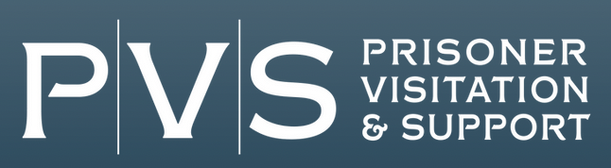
Prisoner Visitation and Support
PO Box 58068, 1501 Cherry St, Philadelphia PA 19102 Tel: (215) 241-7117 no collect calls Email: pvs@prisonervisitation.org Website: www.prisonervisitation.org.
Prisoner Visitation and Support (PVS) is a volunteer visitation program for people incarcerated in federal and military prisons throughout the United States. Our mission is to provide prisoners with regular, face to face contact from the world outside of prison to help them cope with prison life, encourage personal growth, and prepare for successful reentry into society. Our vision is to provide qualified visitors to fulfill all requests for visits by prisoners in every federal and military prison.

Second Chance / STRIVE
6145 Imperial Avenue San Diego, CA 92114-4213 Tel: (619) 234-8888 Email: info@secondchanceprogram.org Website: www.secondchanceprogram.org.
Employment help and employment training skills. Free three-week job readiness training and placement. We work with everyone and anyone, including ex-felons. We can place you. No cost. We do not guarantee employment, but we do have an 80% placement rate.

Volunteers of America Correctional Reentry Services
1666 Duke St, Alexandria, VA 22314 Tel: (703) 341-5000 Website: www.voa.org/correctional-re-entry-services. We provide services to help offenders successfully transition from prison to a productive life in the community and we help rehabilitate adult offenders and steer youth to set new, positive directions for their lives. Our services include halfway houses and work-release programs, day reporting, diversion and pre-trial services, residential treatment, family supports, and dispute resolution and mediation services.

